Autonomous Theft Proof Delivery Robot For Food & Ecommerce

ABSTRACT

This is the generation of robotics and automation, moreover COVID pandemic has increased the need of touch free interactions. So to boost ecommerce and food deliveries without the spread of infections due to human contact we here propose an autonomous delivery robot system.
The robot is designed with raspberry pi board to ensure the complete robot working. The robot is controlled by a 4 wheel drive and remotely controlled via a RF remote. Also the bot has an upper section to carry packages on it that can be opened only by intended recipients. This anti theft mechanism eliminates the risk of any robot thefts and ensure human like delivery.
Also the robot is equipped with a ultrasonic sensor to avoid dashing into people or objects.
The control team monitor the robot direction via a remote camera to easily navigate the robot. And check for any theft attempts. The robot consists of a speaker to interact with customers and make a sound to alert them to open the door when bot arrives. Also the speaker is used to make noise if a theft attempt is made along with a siren system.
The bot is able to deliver food and packages upto 10 kg using its powerful 4 wheel DC motor drive system. The rf control with long range camera allow it to deliver as well as thwart any theft attempts using the on board siren system.

BLOCK DIAGRAM
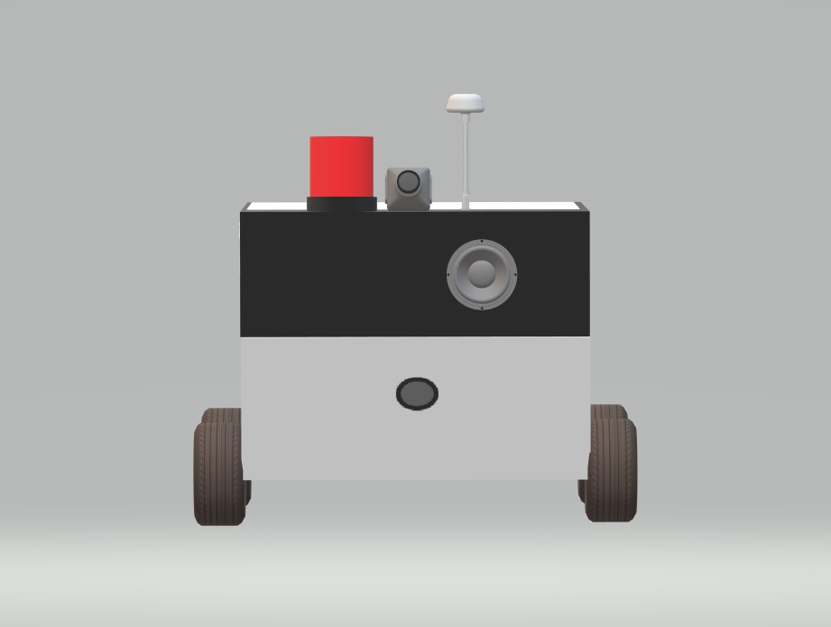

Hardware Specifications

- Raspberry Pi

- DC motors

- Long Range Remote Controller

- RF Receiver

- Remote Camera

- Transmitter Receiver Antenna

- Speaker

- Siren

- Li Battery

- Wheels

- Robot Body

- Resistors

- Capacitors

- Diodes

- Transistors

- Supporting Joints & Hinges

- Screws and Nuts

